Jennifer Stegina

9 September 2019

CIS 250

**Unit 3 Guided Practice 1**

The following questions come from the Task examples of each section of Chapter 7 in your textbook.

After you are finished, please submit the Microsoft Word file that contains screenshots of the SQL script and the resulting tables. Your document should be named **U3_GuidedPractice1_Lastname.docx**.

(7-2) Question 1

From the 1_employees table, list the *employee_id, first_name*, and *hire_date* of all the employees. Add another column showing the hire date formatted in the form *mm-dd-yyyy* followed by the time. Sort the rows of the result by the *employee_id*.

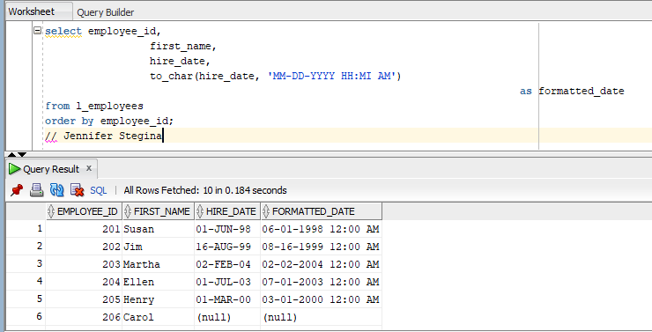

(7-3) Question 2

Insert a new row into the sec0703_lunches table. Use the following data:

* *lunch_id* = 25
* *lunch_date* = December 5, 2011 at 11:30 a.m.
* *employee_id* = 202
* *date_entered* = (use the current date and time)

Use a date format, if needed, to enter the date.

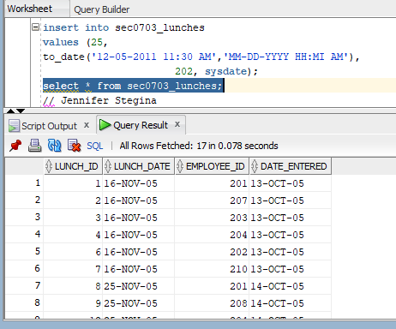 

(7-5) Question 3

Format the *phone_number* column entries of the *sec0705_employees* table. Give each phone number the area code (415) and the prefix 643-. Show two methods of doing this in Access: a GUI method and an SQL method. In the SQL method, show the *employee_id*, *first_name*, *last_name*, and the formatted *phone_number* columns.

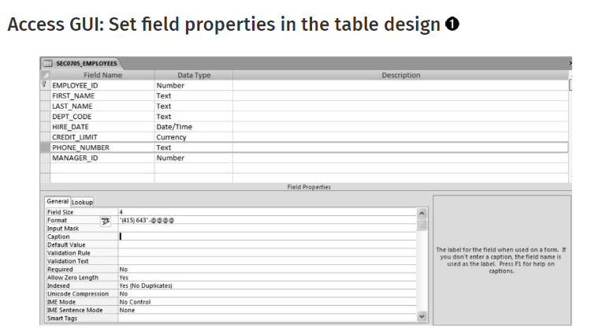

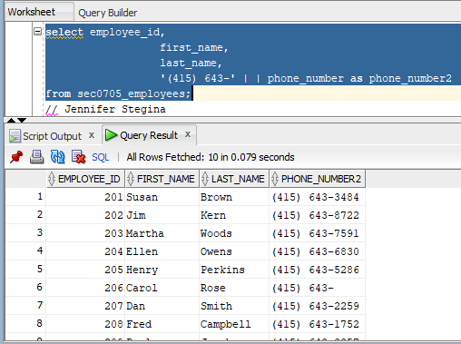

(7-9) Question 4

Create an index on the names of the employees in the *1_employees* table. Include both the *last_name* and the *first_name* values in the index, in that order.

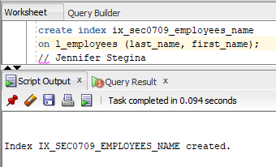

(7-12) Question 5

Find information about the datatypes of all the columns of the 1_employees table.

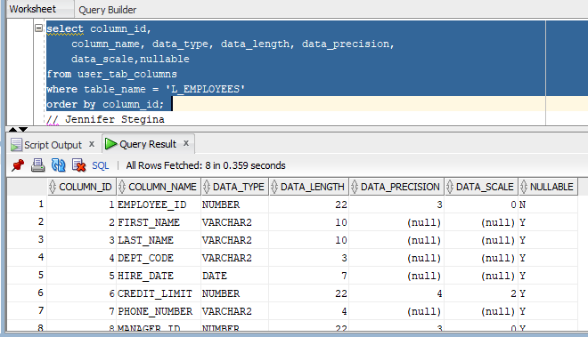

(7-13) Question 6

Find all the information about your sequences in Oracle.

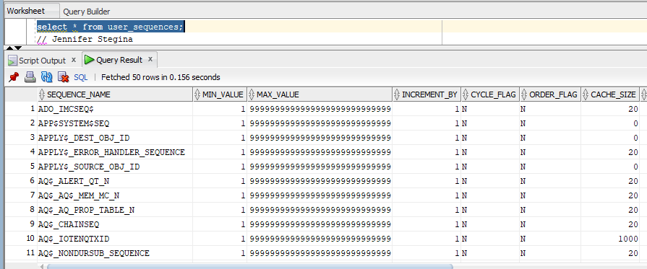

(7-14) Question 7

Find all the indexes on the *1_employees* table and which columns they contain.

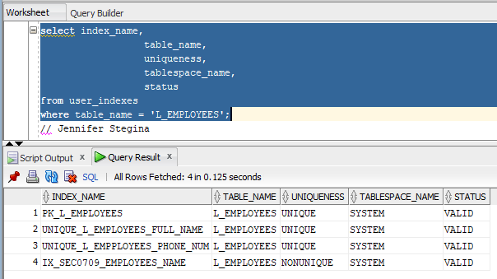

(7-15) Question 8

List all the database objects you own in Oracle, the date each was created, and the most recent date each was changed.

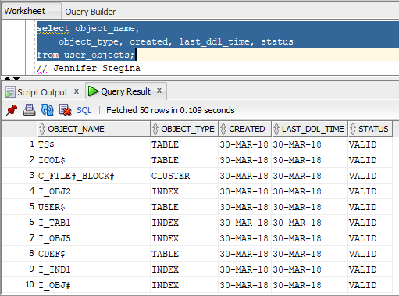

(7-16) Question 9

Find all the tables in the Oracle Data Dictionary that contain information about sequences. To do this, find the names of all the tables with the letters “SEQ” in them. Also list the comments about these tables.

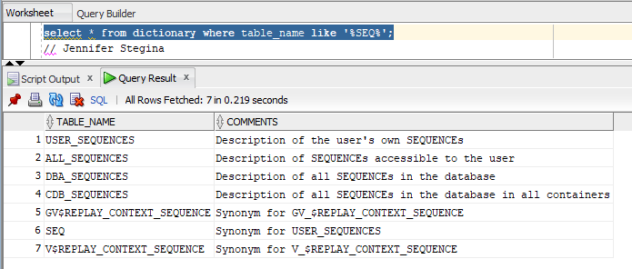

(7-17) Question 10

Find the meaning of all the columns of the *all_sequences* table.

